Colorado Cancer Fund 2018 Grant Cycle
Funding Opportunity Announcement

TO: Colorado Cancer Coalition Task Forces, Colorado Cancer Coalition members and cancer partners

FROM: Paula Marchionda, MD, Vice Chair of the Colorado Cancer Coalition
Madeleine Kane, MD, Past Chair of the Colorado Cancer Coalition

RE: Colorado Cancer Coalition Funding Opportunity

DATE: January 3, 2018

Your organization is invited to submit a completed grant application by January 31, 2018. Please keep your completed application packet to no more than seven pages; longer proposals will not be accepted. All applications will be reviewed by the Colorado Cancer Fund Advisory Committee.

Email an electronic copy of your completed application to thecoloradocancercoalition@gmail.com
by 5:00 pm January 31, 2018

If you have any questions about the application process, please contact Christi Cahill at 303-692-6347 or thecoloradocancercoalition@gmail.com.

This is an open call for proposals on any cancer-related topic. However, priority will be given to applications that meet one or more of the following criteria:
- Projects that address skin cancer prevention, HPV vaccination, or encourage healthy behaviors among cancer survivors
- Projects that target rural/frontier populations
- Projects submitted by organizations involved with the Colorado Cancer Coalition. Coalition Task Forces are highly encouraged to apply.

The intent of Colorado Cancer Fund is to help reduce the burden of cancer in Colorado by improving early detection and expanding existing education and prevention efforts, screening and quality of life services throughout Colorado for populations who are currently underserved.

Overview of the Colorado Cancer Fund
The Colorado Cancer Fund is a voluntary check-off program on the Colorado State Income Tax Form and a part of the Checkoff Colorado program. The goal of the Colorado Cancer Fund is to help reduce the burden of cancer in Colorado by improving early detection and expanding existing education, screening and quality of life services throughout Colorado for populations who are currently underserved. The Colorado Cancer Fund is a program of the Colorado Cancer Coalition (referred to as the Coalition throughout this document), which serves as the statewide collaborative working to eliminate the burden of cancer in Colorado.
For more background information, visit the following websites:
- Colorado Cancer Coalition: www.coloradocancercoalition.org
- Colorado Cancer Fund: https://www.coloradocancercoalition.org/colorado-cancer-fund/
- Checkoff Colorado Fund: www.checkoffcolorado.com

Details of the Request for Proposals (RFP)
This Request for Proposals (RFP) contains instructions for proposals; information on the grants that will be awarded and mandatory requirements, which must be met to be eligible for consideration and payment, if approved.
Priorities:
- The Colorado Cancer Fund Advisory Board seeks to award at least one grant in each of the following five regions of Colorado: Southeast, Southwest, Northwest, Northeast, and Denver metro area. Appendix B illustrates the boundaries of these regions.
- Priority will be given to proposals that address skin cancer prevention, HPV vaccination, or encourage healthy behaviors among cancer survivors. Within these priority areas, proposals that target rural and frontier populations will be given priority consideration.
- Priority will also be given to organizations involved with the Coalition. Coalition Task Forces are highly encouraged to apply.

If you have questions about this RFP or whether your project is a good fit for this opportunity, contact Christi Cahill, Cancer Outreach Specialist, at thecoloradocancercoalition@gmail.com prior to completing the application.

Proposals must be sent electronically on or before January 31, 2018 at 5:00 pm to thecoloradocancercoalition@gmail.com. Proposals lacking any of the requested information and/or signatures will not be considered. A confirmation email will be sent upon receipt of the application. Incomplete and late proposals will not be accepted.

Key Information
Who is eligible to apply? | Collaborative efforts are encouraged; however only one application per entity or task force will be accepted. Fiscal agents are allowed to apply on behalf of multiple organizations. Individuals are not eligible to apply. Previous grantees (other than state level government/health department) are eligible.  The following types of organizations may apply:  - Nonprofit organizations  - Community-based programs  - Private sector entities  - Regional, county and local health departments  - Regional, county and local governments
How much funding can I apply for? | Grants are usually awarded up to $5,000, but under special circumstance larger awards may be considered. The grant cycle is estimated to begin March 15, 2018 and will end March 15, 2019. This year, $55,000 will be available from 2016 taxpayer contributions.
Important Dates | Proposal Submission Deadline  Notification of Awards  Distribution of Grants  Grant Period  Informal report & marketing content**  Final Grant Report Due  *The grant period is one year with a no cost extension  ** Marketing materials and status updates will be used to promote the Cancer Fund during the 2019 tax season. | January 31, 2018 by 5:00 pm  March 5, 2018  March 15, 2018  March 15, 2018 – Mar 15, 2019*  December 15, 2018  April 30, 2019
What else do I need to know? | The contents of the approved applications will become contractual obligations. By submitting this application, you agree to the terms outlined in Appendix A: Grantee Requirements.

Funding Process
These are competitive grants that will be reviewed by an independent body (the Colorado Cancer Fund Advisory Committee) and scored based on scientific integrity and potential impact. This Committee will consider the factors outlined in the Evaluation Factors table in Appendix C when evaluating applications.

Publications & Publicity
The Colorado Cancer Fund grants are made possible by generous voluntary contributions from Coloradans on their state tax returns. To continue providing grants, it is imperative that we promote the fund. Those selected for funding will be expected to help promote the Colorado Cancer Fund marketing initiatives in 2018 and 2019. All publications, abstracts, or similar communications resulting from work supported by the Colorado Cancer Fund must acknowledge this support by inclusion of the statement: "Supported by a grant from the Colorado Cancer Fund.” Funded projects will also be required to help market the Colorado Cancer Fund during 2019 tax season. This includes sending the Coalition an update of activities and any marketing materials to help promote the Colorado Cancer Fund.

Final Grant Report
Funded projects are expected to provide a one to two page final report stating the outcomes of the project, due no later than April 30, 2019. The final report should be concise and should include a summary of the project goals accomplished, how objectives were met, other achievements (including unexpected outcomes), challenges or concerns encountered and how they were addressed (if applicable), and a detailed budget expenditure report.

Project Narrative
The application is made up of the five sections outlined below. The final application should be no more than 7 pages (single-spaced, 1-inch margins, times new roman font). Provide only materials which are requested in the application. Please assign page numbers to your proposal.

- COVER PAGE/ PROJECT SUMMARY AND CONTACT (not to exceed 1 page)
- Project Title
- Applicant (Organization) Name(s)
- Address
- Contact Name
- Day Phone
- Preferred email address
- Amount Requested
- Geographic Region(s) Project Will Serve (as specified in Appendix B)
- Two-paragraph summary of the proposal.

- SCOPE OF WORK (not to exceed 3 pages)
  - Statement of Need: What is the need? What evidence is there that the stated problem(s) is a high priority for the community (e.g. results of needs assessment, incidence and prevalence studies and/or community surveys)?
  - Rationale: How will this project effectively address the problem? Why do you think it will work?
  - Target Population: Who is the target population for this project (e.g. males 18-35 years of age, women 45-60 years of age, children of certain ages), and what geographic area will this project serve? Is this target population adequately served by existing services and programs? Where will the project be conducted?

Project Plan

State Project Goal: Please outline your project plan using the SMART Objective system (S=specific, M=measurable, A=achievable, R=realistic, T=time based).

What steps or activities will accomplish the goal and objectives?

Describe the approach and timeline for the project. Who will carry out the plan?

What evidence is there to support the project’s approach?
  - Applicants are encouraged to refer to the Colorado Cancer Plan (www.coloradocancerplan.org), a publication of the Colorado Cancer Coalition.
  - Evidence-based practices, projects, or programs are encouraged. Information on Evidence-based Practices is published by organizations such as the Centers for Disease Control and Prevention’s Community Guide (www.thecommunityguide.org/cancer) and National Cancer Institute’s Research Tested Intervention Programs site (https://rtips.cancer.gov/rtips/index.do)
  - Emerging and innovative practices and programs that have not yet been formally evaluated but show promise in being effective will also be accepted.

Provide details on evaluation and measurement methods. What will determine if the project is successful?
  - Proposals must specify the evaluation measures which will be used to assess the project’s impact on the target community. These measures may include activities and results or evidence of impact.

Meeting the Colorado Cancer Fund Purpose and Coalition Involvement: Briefly outline how the project meets the goal of the Colorado Cancer Fund/Colorado Cancer Coalition/Colorado Cancer Plan. Briefly outline how participating organization(s) are involved with the Coalition (if applicable).

Collaboration and Community Resources: Are there other entities in your community doing a similar project? If so, who are they and to what extent are the projects similar or different? Are there plans to coordinate activities with existing projects? Explain why or why not. How will you collaborate with other entities to make the project more effective and not duplicative?

Barriers/Obstacles: What problems must be solved, or obstacles overcome to commence and/or complete the project?

Sustainability: Is this a one-time project or a project that could or should be self-sustaining? How and by whom? Are there possibilities of collaborating with other agencies to ensure the project will continue?
- Budget Justification (not to exceed 1 page)
        - Narrative Budget Justification: Please include brief explanations for all the categories mentioned in your budget worksheet.
        - Budget Worksheet: Please use the general format of the Budget Worksheet in Appendix D to detail expenses.
- W-9
              - If more than one organization is participating in the application, include the W-9 from the lead organization that will house the project money.
              - Task forces of the Colorado Cancer Coalition should work with Trailhead Institute to complete this form.
- Affirmation of Validity of Application (Appendix E)

APPENDIX A: Colorado Cancer Fund Grantee Requirements
Grant Payments
Work should not begin on the grant until you receive a notice of approval and consent to move forward with the grant. The Colorado Cancer Fund is not liable for any cost incurred by applicant prior to issuance of a legally executed contract. No proprietary interest, of any nature, shall occur until a contract is awarded and signed by all concerned parties. One payment will be made upon approval of the RFP. All work is to be completed by March 15th, 2019.
Reporting Requirements
Each grantee is expected to submit a final report by April 30, 2019 via e-mail to thecoloradocancercoalition@gmail.com. The final report should be concise and no longer than two pages in length and should include the following:
- Project goals accomplished
- How objectives were met
- Other achievements (including unexpected outcomes)
- Challenges or concerns encountered and how they were addressed (if applicable)
- A detailed budget expenditure report. Any unused funds, must be sent back to the Colorado Cancer Coalition by April 30, 2019.

Other Considerations
- Any printed materials, graphic representations, educational materials, or other audiovisual products that were created as a result of the grant should accompany the final report. Acknowledgement that materials were produced with funding from the Colorado Cancer Fund should be included on materials.
  - Materials developed as a result of the grant are under the ownership of the grantee. The Colorado Cancer Fund may wish to use any or all information or material developed through the grant.
- Grantees are expected to help create awareness about the existence of the Colorado Cancer Fund and to support the future of the program. For example, grant recipients may be asked to submit a brief article for partner newsletters or the Coalition’s website, and may also be required to provide educational materials about the fund to partners and people served by the Fund.
- Following the review process, the Colorado Cancer Fund reserves the right to negotiate components of the Scope of Work and budget with the applicant, which may delay the start of work and the funding period.
  - The Colorado Cancer Fund reserves the right to reject any or all proposals and to waive informalities and minor irregularities in proposals received and to accept any portion of a proposal or all items proposed.
- Amending the use of your funds is permitted, but must be done in collaboration with the Colorado Cancer Fund. Approval by the Colorado Cancer Coalition Steering Committee (thecoloradocancercoalition@gmail.com) is required before revising your project or reallocating the grant award.
- You may be asked to present the progress or outcomes of your project to the Colorado Cancer Fund Advisory Committee or the Colorado Cancer Coalition. If so, details will be provided.
- The applicant shall comply with all applicable state and federal laws, rules and regulations involving non-discrimination on the basis of race, color, religion, national origin, age, or sex.

Appendix B: Map of Colorado Cancer Coalition Regions

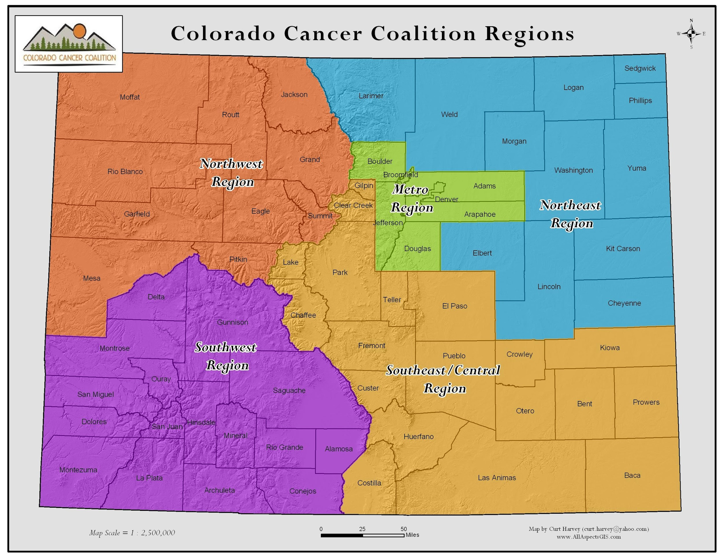

Appendix C: Scoring Rubric
Evaluation Factors |  | Maximum Points
Scope of Work | - Demonstrated need for the project in the community  - Rationale for the project  - Population and geographic area and Colorado Cancer Coalition region served | 70
Project meets Purpose of the Colorado Cancer Fund/ Coalition/ Cancer Plan | - Does the project align with Coalition/Cancer Plan goals? | 10
Collaboration, Measurement and Evaluation | - Potential for measurable, long-term impact  - Other resources and collaborative partners to support the implementation and sustainability of the proposed work | 10
Utilization of Budget Dollars | - Cost-effectiveness of the project | 10
TOTAL POINTS |  | 100

Appendix D: Budget Narrative and Justification
Budget Worksheet
Expenses | CCF Grant Request Program Costs
Staffing (salary and benefits)
Program/Service Costs
Equipment
Contractors, Vendors, etc.
Informational or Educational Materials
Supplies
Printing/Copying/Postage
Meeting Costs
Travel Expenses
Other: (Please specify)
Total Requested Grant Amount

Narrative Budget Justification: Please include brief explanations for all the categories mentioned in your budget worksheet, above. For example:

- Staffing (salary and benefits)– Explain the specific need for salary support for staff. Identify project responsibilities of each identified person included in the budget. For salary coverage, provide the amount per hour and estimated hours per week. (e.g., 30 hours at $10/hour=$300).
- Program/Service Costs – Explain the cost of intervention materials per anticipated participants (if applicable)
- Equipment – Explain the need for equipment needed and how it relates to the overall project (if applicable).
- Supplies – Briefly describe the need for specific supplies and an explanation of how the cost has been estimated. (e.g., flipcharts needed for planning meetings (2 @ $15/chart = $30)
- Travel Expenses – Explain need for all travel and anticipated expenses. Travel must be directly related to proposed activities.

Appendix E: Affirmation of Validity

Affirmation of Validity of Application and Grantee Compliance

This form MUST be included with your application.

I, the undersigned, do hereby attest that the information contained within this application is true to the best of my knowledge and my organization will abide by the guidelines set forth in this document. I also agree to the Colorado Cancer Fund Grantee Requirements outlined in Appendix A.

Signed: ________________________________ Date: _______________________

Name: __________________________________

Title: __________________________________

Organization: __________________________________________________________

